Sun Jun 9, 2019

UNFOLDING: Today’s Motorcycle Death of Randy Byrd and the Connection to Murdered Sen. Collins-Smith (Pocahontas, Arkansas)

Randy Byrd

Randy Byrd of Pocahontas was going north on a 2005 Yamaha motorcycle on Highway 67 around 10:45 a.m. June 8 when the crash occurred:

https://www.kait8.com/2019/06/08/traffic-alert-crash-reported-highway-randolph-county/

One of our insiders stated:

The motorcycle driver (Randy) “pulled right in front of the semi.”

In March 2018, Byrd assaulted the ex-husband of murdered senator, Linda Collins-Smith, Judge Phillip Smith. The reasons for the attack are unconfirmed:

https://neareport.com/2018/03/19/man-arrested-assaulting-judge-pocahontas-grocery-store/

Byrd also faced charges for being associated with an Arkansas oxycodone ring:

https://www.justice.gov/usao-edar/pr/physician-admits-illegally-distributing-39000-pills-pleads-guilty-federal-conspiracy

“Of the 18 individuals federally charged with Dr. Johns, five have pleaded guilty to conspiracy charges, including Vanessa Byrd (plea entered 10/6/16); James Spiker, Jr. (plea entered 10/9/16); Aaron Cochran (plea entered 11/9/16); Andy Byrd (plea entered on 11/21/16); Donna Cearns (plea entered 1/4/17); and Christine Zeman (plea entered 1/23/17). Charles Mason’s charges were dismissed. Only Vanessa Byrd—who received 37 months’ imprisonment—has been sentenced. Trial on the remaining defendants is set for March 27, 2017.”

https://neareport.com/2018/03/19/man-arrested-assaulting-judge-pocahontas-grocery-store/

Little Rock Doctor Admits to Selling Prescription Drugshttps://www.kark.com/news/local-news/little-rock-doctor-admits-to-selling-prescription-drugs/665704033
Lane Keller
LaneExplains.com

Sun Jun 9, 2019

Senator Linda Collins-Smith and CPS / DHS

Researcher Michaele Walker disclosed that Collins-Smith was due to give Grand Jury testimony the Friday following the discovery of her body.

https://www.youtube.com/watch?v=-X_vxIUP_wk

Prior to her death, Collins-Smith had been actively tracking Arkansas DHS’ missing $27 million dollars, an amount that spiraled to 53 million dollars+ then into the billions traceable on a second set of books. This discovery linked the Clinton Foundation companies and the State of Arkansas sex-trafficking operation.

https://creativedestructionmedia.com/investigations/2019/06/07/breaking-murdered-arkansas-former-gop-state-senator-believed-she-was-closing-in-on-child-trafficking-ring-in-arkansas-state-government/

Here are some facts:

Human sex trafficking is a MULTI TRILLION DOLLAR industry. It is very possibly the most lucrative industry in the world.

The number of missing children per day, week, month and year are ASTRONOMICAL, and bear no relation to official numbers or to amounts imagined by any reasonable individual.

American children and babies are being actively stolen, shipped and resold to buyers and slave markets around the world. “Aborted” fetus,’ kids adopted into “loving” families, and children “protected” by alleged government agencies CPS & DHS are being actively trafficked.

Chances are your school guidance counselor, teacher or principal who so-responsibly reports sidelined kids to CPS has no idea of the depth of the travesties (and depravity) possibly awaiting that child. But few if any other options exist other than these official channels for those trying to help. Multiple volunteer agencies simply feed back into the system.

The corruption is deep and dark. Chances are that every state in the country is infiltrated to the highest levels.

CPS & DHS are private, non governmental agencies funded by federal grants. These grants INCENTIVIZE the removal of children from homes in direct opposition to CPS’ stated position of removing children from birth parents being the last resort.
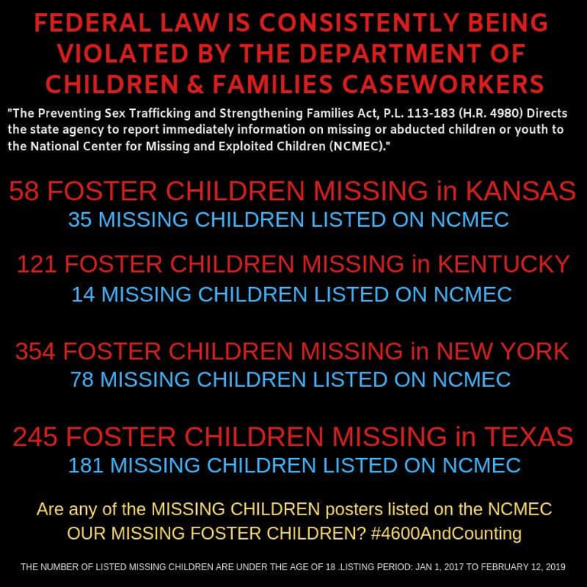

Federal Grants are based on QUOTAS of removed children, with the quotas increasing as each previous quota is reached. One child short of your quota? Sorry, no funding.

CPS employees are INCENTIVIZED to remove children from homes, again, in direct opposition to CPS’ stated position of child removal being a last resort, through the receipt of PERSONAL BONUSES that far exceed their salaries.

LINKS

State’s Child Protection Agencies Collude with Judges to Defraud Federal Government
https://cbliss.wordpress.com/2008/09/14/state’s-child-protection-agencies-collude-with-judges-to-defraud-federal-government/?fbclid=IwAR3VOtzSliuUc6NgZmci7L1GC4NO5iUwbqYXpau6eDU-r4-w0FxiZvR_9J4

Victims Rights Arkansas, Last Speech made by Linda Collins-Smith
https://www.facebook.com/VictimsRightsAR/videos/2454769101200346/

While Little Rock Burns
https://www.conduitforaction.org/while-little-rock-burns/

Collins-Smith Return tweet re: NXIVM

Asa & The “Corruption State”
https://www.conduitforaction.org/the-corruption-state/?fbclid=IwAR0ODby5ja0KuC-WFoWtuO6f_oFFAQM6yNkPJseK-2-D1sX7JkSc86c3yZU

The devil you know.’ SC residents are selling family members into the sex trade

https://www.thestate.com/news/special-reports/article226639189.html?fbclid=IwAR30-umvx13eqnnUe7WTRjumuKyS9eJ6kTrx9Vi9gcIuAvmZu5fAJFiMjBc

Child Protective Services Stealing Kids for Profit | Government Kidnaps | Sex Trafficking

https://www.youtube.com/watch?v=_P0lq8_b0v0&feature=youtu.be&fbclid=IwAR1wCc6Ma3NeVZ7PF8GKBwKS5SOIkstHNzioNB2M9WQ_rFnvltJFSV_Vhcs

Human Trafficking in Shipping Containers

http://www.containerquote.com/human-trafficking?fbclid=IwAR0wvhtdwnq5z-Qg3bXDHdjrMDprF_OkGXQ-FUcMl2dWxZKg4fzRp8dWgEo

America’s strategic infrastructure compromised: Did Clinton pay-to-play arrangement hand over port container operations inside national security nexus to wealthy foreign associates?

https://www.1776channel.com/2015/05/24/us/americas-strategic-infrastructure-compromised-did-clinton-pay-to-play-arrangement-hand-over-port-container-operations-inside-national-security-nexus-to-wealthy-foreign-associates/?fbclid=IwAR2FZR3hHlDnJtGV46ZLPxIBz6Z1kWMiBXYbxC75W1BODHTTdCZxExEET3I

Ohio had almost 20,000 missing children reports in 2018

http://www.sanduskyregister.com/story/201905240020?fbclid=IwAR26LY7oBExkne-v55JllPKL1Ue0cdk9LcwNm89xQ6TyyahU20hy-xYm98M

Mom says test results from forgery suspect’s lab impacted custody battle

https://www.wsfa.com/2019/05/28/mom-says-test-results-forgery-suspects-lab-impacted-custody-battle/

(Image link:
https://www.dropbox.com/s/x3wmt7z5qgyzjt1/sex%20trafficking%20descrepencies.png?dl=00

Lane Keller
LaneExplains.com

Sun Jun 9, 2019

Is the Death of Sen Jonathon Nichols Related to the Murder of Sen. Linda Collins-Smith?

On Thursday night, one night after the discovery of former Arkansas Senator Linda Collins-Smith’s body, former Oklahoma state senator Jonathan Nichols was discovered dead inside his Norman, OK residence from an apparent gunshot.

https://people.com/crime/former-state-senator-found-dead-gunshot-second-time-2-days/

Pocahontas, AK is located approximately 455 miles from Norman, OK, or a 7 hour drive straight through the Ozarks:

Senator Jonathon Nichols was a child’s rights advocate, and known sex trafficking opponent.

Senator Nichols Targets Child Predators with Death Penalty, Child Abuse Response Team http://www.oksenate.gov/news/press_releases/press_releases_2006/pr20060526d.htm

Nichols to author bill creating child abuse response team
https://www.normantranscript.com/news/local_news/nichols-to-author-bill-creating-child-abuse-response-team/article_2f09f149-992a-5619-86e4-722a2e0f9c48.html

Is there a Connection?
https://www.anonews.co/3031-2/

Nichols Blasts Supreme Court Decision in Child Rape Case

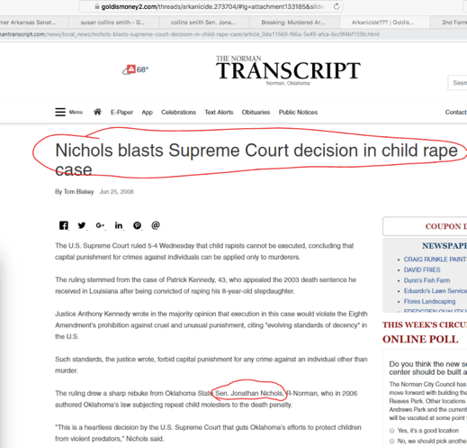

Lane Keller
LaneExplains.com

Image link s:
https://www.dropbox.com/s/0vy2irr9batob5u/map.png?dl=0
https://www.dropbox.com/s/94trxnir0u0cc9o/sen%20nichols%20OK.png?dl=0)

